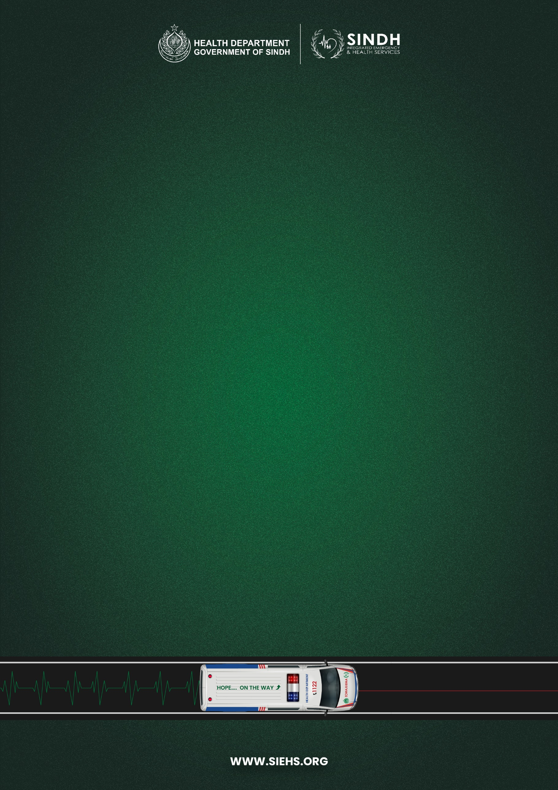

**Ambulance Maintenance**

**STANDARD OPERATING PROCEDURES**

|  |  |
| --- | --- |
| **Document no:** | SIEHS-FT-SOP-01 |
| **Issue no:** | 04 |
| **Issue Date:** | November 15, 2024 |
| **Pages:** | 11 |

|  |  |  |
| --- | --- | --- |
|  | **Prepared** | **Reviewed & Approved By** |
| **Name:** | Muhammad Abbas Nomi | Lt. Col. (R) Ali Akbar Jhandeer |
| **Designation:** | Manager Fleet | Head of Support Wing |
| **Signature:** |  |  |

**TABLE OF CONTENTS**

1. PURPOSE 2

2. SCOPE 2

3. RESPONSIBILITY 2

3.1. Manager Fleet & Workshop: 2

3.2. Assistant Manager Fleet & Workshop: 2

3.3. Fleet Data Analyst: 3

3.4. Fleet Coordinator: 3

3.5. Fleet Billing Coordinator: 3

3.6. Fleet Maintenance Analyst: 4

3.7. Workshop Supervisor: 4

3.8. Fleet Incharge: 4

3.9. Fleet Insurance Incharge: 4

3.10. Store Analyst: 5

3.11. Service Advisor: 5

3.12. Mechanic: 5

3.13. Electrician: 6

3.14. AC Electrician: 6

3.15. Fabricator: 6

4. PROCEDURE 6

4.1 Periodic / General Maintenance 6

4.2 Body / Accident Repairs 7

4.3 Maintenance/Repair from External/Outsourced Workshops: 7

4.4 On Site Repairs 8

5.0 Job Duration: 10

5.1 Basic Engine Components 11

5.2 In-house Workshop Operations: 11

6. REASON OF CHANGE 11

# PURPOSE

The objective is to maintain the SIEHS ambulance fleet to optimize fleet performance at minimum cost without compromising repair/ maintenance quality and ensure minimum off-road time.

# SCOPE

The following SOP will cover all kinds of repairs including mechanical, body, electrical, or fabrication to be carried out at the in-house facility/ external vendors (if required).

# RESPONSIBILITY

## Manager Fleet & Workshop:

1. He is overall responsible for the entire Fleet management.
2. Manage all Fleet, in-house/ mobile workshops & outsourced workshops & parts-related activities.
3. Ensure full compliance, responsible for coordinating with all concerns in case of any ambulance encounter in an accident to ensure its post-accident formalities & 3rd Party operations.
4. Ensure quality of Rear Fabrication Repair & Maintenance work.
5. Discipline of staff to be catered.
6. Ensure completion of vehicle repair and maintenance records.
7. Monitor and report on parts usage to identify potential cost savings opportunities. Ensure all repairs and maintenance.
8. Proactively identify opportunities for improvement in repair maintenance processes and procedures.
9. Implement new maintenance techniques and best practices to enhance efficiency and service quality.

## Assistant Manager Fleet & Workshop:

1. Assistant Manager Fleet in managing all Fleet, in-house/ mobile workshops & outsourced workshops & parts-related activities.
2. Assistant Manager Fleet in ensuring full compliance, responsible for coordinating with all concerns in case of any ambulance encounter in an accident to ensure its post-accident formalities & 3rd Party operations.
3. Ensure that all data is being updated by fleet data analysts related to the fleet.
4. Monitor key workshop performance metrics (e.g., downtime, repair costs, crew satisfaction) and report progress regularly.
5. Monitoring of Vehicle repair and maintenance record.
6. Responsible for making/ updating of all kind ppt presentation in connection with fleet in connection of presentation to senior management.
7. Responsible for finalizing daily vehicle on/off road record for further submission to senior management in coordination with operations.

## Fleet Data Analyst:

1. Manage all the fleet-related Data Maintenance, data reporting, and monthly reports, and highlight any discrepancy issues under the supervision of the Manager Fleet.
2. Prepare Daily, Weekly, and Monthly Reports of Vehicle accidents, Repair and Maintenance data, and Dashboards of Fleet Activities and analyze them properly.
3. Ensure coordination with coordinators, workshop supervisor, and fleet In-charge to ensure proper maintenance of data.
4. Making/ updating vehicle repair and maintenance record.

## Fleet Coordinator:

1. Coordinating with operation and workshop staff to ensure Ambulances on-road.
2. Prepare and circulate updated status of on-road Ambulances to concerns.
3. Data collection, monitoring of daily fuel reports, accident reports, on-road ambulance data, and repair and maintenance data.
4. Maintain accurate documentation of all maintenance activities for compliance purposes.
5. Report critical issues or delays promptly to management for timely intervention.
6. Ensure proper filling of job card in all means.
7. Ensure fleet staff attendance through biometric/ face recognition device.
8. Responsible for closing all completed work orders well in time.

## Fleet Billing Coordinator:

1. The Fleet Billing coordinator is responsible for verifying vendor invoices.
2. The Fleet Billing coordinator is responsible for raising PR against required items.
3. The Fleet Billing coordinator is responsible for following up with Finance, Procurement, and other stakeholders.
4. The Fleet billing coordinator is responsible for maintaining the record of all fleet bills & invoices
5. The Fleet billing coordinator is responsible for follow-up on expense claims & per diems of fleet staff.
6. The Fleet billing coordinator is responsible for comparing price/ rate list with old/ new differences.
7. Responsible for timely ensuring of PR and PO submission and processing.
8. Responsible for ensuring timely payment process and consultation with Fleet manager and HOD.

## Fleet Maintenance Analyst:

1. Perform routine maintenance and preventive checks on ambulances (oil changes, tire rotations, etc.).
2. Diagnose and troubleshoot mechanical, electrical, and equipment malfunctions in ambulances.
3. Repair and replace defective parts and systems efficiently and accurately.
4. Maintain detailed records of all work performed on each ambulance in hard format.
5. Follow instructions of the Workshop Supervisor for efficient workflow and parts availability (in the East region).
6. Follow instructions of the Manager Fleet for efficient workflow and parts availability (in North, South and Central region).
7. Stay updated on advancements in ambulance technology and maintenance practices.
8. May assist with training of new mechanics or special projects as assigned.

## Workshop Supervisor:

1. Motivate and guide the workshop team (mechanics, technicians) to achieve operational excellence.
2. Delegating tasks effectively for efficient workflow.
3. The supervisor will oversee routine maintenance schedules and troubleshoot mechanical, and electrical faults keeping in view timely completion across the ambulance fleet.
4. Prioritize repairs based on urgency and potential impact on emergency service delivery.

## Fleet Incharge:

1. Conduct thorough quality checks on completed work before releasing ambulances back into service.
2. The fleet in charge is responsible for maintaining Fleet Inspections.
3. The Fleet In charge is responsible for the overall facility management of the Workshop.
4. The Fleet In charge is responsible for prioritizing and overlooking downtime for the repair of the fleet.

## Fleet Insurance Incharge:

1. Oversee repair and fabrication of damaged ambulance bodies and components based on 3rd party insurance claims.
2. Accurately estimate repair costs adhering to SIEHS standards and insurance guidelines, negotiating adjustments as needed.
3. Manage 3rd party insurance claims process, including liaising with surveyors and finance, obtaining approvals, and ensuring complete documentation.
4. Guarantee repairs meet SIEHS safety and operational requirements alongside insurance company quality standards.
5. Prioritize and schedule repairs to minimize ambulance downtime and maintain service availability.
6. Inspect completed repairs through insurance claim for quality and compliance before releasing ambulances back into operation.
7. Maintain detailed records of repair work, cost estimates, and insurance claims documentation.

## Store Analyst:

1. Maintain accurate inventory levels of spare parts and consumables for efficient workshop operations.
2. Identify and notify fleet coordinator of required parts for ambulance repairs and maintenance, ensuring timely availability.
3. Receive and properly store incoming parts, verifying quantities and specifications against purchase orders.
4. Maintain and update detailed records of all parts and tools inventory.
5. Manage and organize the inventory of old parts disassembled from ambulances, following proper disposal or recycling procedures.
6. Issue parts and tools to workshop staff upon request, recording all transactions and maintaining stock control.
7. Maintain cleanliness and order in the storeroom, ensuring proper storage conditions for all parts.
8. Assist with workshop operations as needed, including receiving deliveries, packing returns, and supporting inventory audits.
9. Ensure record of all Enter/Exit spare parts of vehicles being utilized.

## Service Advisor:

1. Serve as the primary point of contact for ambulance crews and Fleet management regarding workshop services.
2. Receive and assess incoming ambulances, documenting their condition and repair needs in detailed job cards.
3. Collaborate with workshop supervisors to prioritize and schedule repairs based on urgency and operational impact.
4. Verify and approve completed work on job cards, ensuring services meet SIEHS standards and crew expectations.
5. Provide accurate repair cost estimates and obtain necessary approvals from management.
6. Communicate effectively with all stakeholders, keeping crews and management informed about repair progress and any delays.
7. Maintain accurate records of service requests, job cards, and repair histories for each ambulance.

## Mechanic:

1. Perform routine maintenance and preventive checks on ambulances (oil changes, tire rotations, etc.).
2. Repair and replace defective parts and systems efficiently and accurately.
3. Follow instructions of the Workshop Supervisor/ Fleet in charge/ Manager for efficient workflow and parts availability.
4. Perform overall Mechanical work of Fleet.

## Electrician:

1. Diagnose and repair electrical malfunctions in ambulances, including lighting, communication systems, rear cabin wiring, and auxiliary systems.
2. Install, maintain, and upgrade electrical components and wiring in ambulances including usage of ECU Scanner.
3. Troubleshoot and resolve electrical issues reported by ambulance crews or workshop staff.
4. Follow instructions of the Workshop Supervisor/ Fleet in charge/ Manager and other mechanics for efficient workflow and parts availability.

## AC Electrician:

1. Diagnose and repair electrical and control systems within ambulance air conditioning units.
2. Install, maintain, and troubleshoot AC components like compressors, condensers, evaporators, and control panels.
3. Perform preventive maintenance checks on AC systems to ensure optimal cooling performance and efficiency.
4. Respond promptly to AC malfunctions reported by ambulance crews or workshop staff.
5. Follow instructions of the Workshop Supervisor/ Fleet in charge/ Manager and other mechanics for efficient workflow and parts availability.

## Fabricator:

* 1. Perform overall fabrication work of Fleet.
  2. Minor electrical items replacement in the fleet
  3. Will coordinate with the fleet in charge/manager for fabrication work.

# PROCEDURE

## Periodic / General Maintenance

1. The Station will email to Fleet Department for PM and Repair Maintenance of the vehicle after confirming it, vehicle will be aligned for PM activity.
2. Fleet Department will have to communicate to respective stations and ensure availability of vehicles for periodic maintenance. Follow up emails will be generated in case of delay.
3. If vehicle is not in drivable condition after a breakdown, station/driver will inform Fleet Department to either arrange a mobile team at station or towing service and transfer the vehicle to workshop.
4. In case of vehicle breakdown during emergency call, driver will inform control and command to arrange replacement to transport patient to hospital and take the vehicle to the workshop advice by the Fleet Department.
5. For any job related to Third Party Vendors, Fleet department will evaluate vendors based on criteria considering quality, cost and minimum off road duration possible.
6. All major & minor repairs will be carried out at workshops designated by Fleet Department.
7. Station management will issue a work order in HES for workshop visit of all ambulances.
8. Fleet Department will be the only point of contact for all workshops; Fleet Department will follow up for all repairs and timely job completion and deputed personnel will ensure all jobs done as per agreed terms & conditions. Moreover, Manager Fleet & workshop will randomly visit the workshops to verify quality of work and verify the compliances accordingly.
9. No repair work will be carried out by the workshops without work order in HES.

## Body / Accident Repairs

1. Repairs will be carried out by selective local body workshop*(s)* or Selective 3rd Party Vendors.
2. The driver’s / station supervisors will inform the Fleet Department about accidental damage to the vehicle, raise the Accident Report and Work Order in HES and the driver will deliver the vehicle to the workshop suggested.
3. If a vehicle is involved in an accident during an emergency call, the driver will first inform Command and Control to arrange for a replacement.
4. If a vehicle is involved in an accident during the late evening or night shift, it will be taken to the station. Information will be passed on to Command and Control, Fleet Department and Station management, further process will be followed on next working day.
5. If a vehicle is not in drivable condition after an accident, Fleet Department will arrange towing service through Third Party vendor to transfer the vehicle to advised workshop.
6. Fleet/Administration & Logistics Department will provide all documents *(e.g. driving license, registration book, insurance policy, FIR, signed claim forms)* to workshops for the vehicles under repairs for insurance claims.
7. Fleet Department will provide a monthly accident report, describing damage details, repair cost (if applicable) and responsibility, which will help to P&C and operations to make necessary actions for the reduction of accidents.
8. Fleet Department will be involved throughout the process of repair for major accidents, to monitor the quality of repairs.
9. No repair work will be carried out by the workshops without work order and Accident report in HES.
10. Fleet Department will sign the satisfactory note and process Invoices after complete visual inspection and satisfaction of the carried-out job including branding *(if replaced)* and all body dent/paint work.

## Maintenance/Repair from External/Outsourced Workshops:

1. Fleet Coordinator will be the point of contact for drivers for appointment, repair details or follow up from outsourced workshops. The Fleet Coordinator will coordinate with the Workshop supervisor. Drivers will leave and collect the vehicles from a workshop or wait for the job completion for small jobs, as advised.
2. Drives/Station Supervisors will contact Fleet Department for any breakdown or unusual *(general)* repair requirement of the ambulance.
3. Outsource Workshop will submit all bills by last day of each month, along with copy of approved estimate issued by Fleet department for the payment in case of Non-Contractual Ambulance or item.
4. Fleet Data Analyst maintain the complete record for Outsource Workshop Repairs *(Job Completion Time)* in excel sheet and ON/OFF ROAD Rental Fleet status for calculation of any penalties in monthly invoices as per contract.

## On Site Repairs

1. **Repair & Maintenance Mobile workshop team:** RM Team will perform PM and resolve breakdown issues at station and/or key point. This will help reducing the off-road time and reducing the interest of the person deliberately creating problems to off road vehicles.
2. **RM Team will be able to attend the following issues:**

* Preventive Maintenance (Including All consumables)
* Fabrication related issues
* Rear Cabin Wiring
* Dash board panel buttons for hooter and lights
* Clutch Work
* Minor Mechanical work

1. **Periodic *(Preventive)* Maintenance:** The purpose of periodic maintenance is to restore a vehicle’s performance to the best possible condition, in order to prevent small problems from becoming bigger in the future, and to ensure that the vehicle is safe and conforms to local laws and regulations. The manufacturer therefore specifies certain periodic maintenance intervals, which includes inspection, adjustment or replacement of parts and components.
2. **Mobile Workshop Movement Criteria:**

The mobile workshop will move as per the approved plan by HOD and as per operational requirements.

1. **Mobile Workshop Team:**

The mobile workshop will consist of the following staff:

1. Mechanic
2. Electrician
3. Fabricator
4. Driver plus mechanic

**Periodic Maintenance**

* Inspection
* Adjustment
* Replacement

**Vehicle Properly Maintained**

* Prevention of problems
* Safe Driving
* Conformity to local laws and regulations

**Operational Flexibility**

* Longer vehicle life
* Good driving economy
* Reliable operation

1. **SERVICE LEVEL I**
2. The engine oil and oil filter to be changed.
3. The tires are to be checked for proper air pressure and wear condition.
4. Inspection for leakages, deteriorations or abnormal wear is to be made on the following components: drive belts, radiator & hoses, Shock absorbers & springs, and windshield wipers.
5. A check for all fluid levels including radiator, power steering, brakes, transmission, engine oil and windshield washer fluid. Levels are to be topped off where necessary.
6. All lights and electrical systems (Battery, wiring, PA & Hooter systems) to be checked and corrected if necessary.
7. Vehicle is to be inspected for any minor fabrication issues in the body & patient compartment.
8. Ambulance wash.
9. **SERVICE LEVEL II**
10. All items contained in Service Level I.
11. Inspection of timing belt, timing pulley & cover.
12. A “Wheels off inspection” for all brakes & components.
13. **SERVICE LEVEL III**
14. All items contained in Service Level I & II.
15. Furnish and replace wheel bearings, grease, transmission and transfer oil.
16. **SERVICE LEVEL IV – Detailed Quality Inspection**

This is a detailed Inspection covering all previous Service Inspection levels with additional checks.

# 5.0 Job Duration:

1. All timelines are applicable with respect to the availability of spare parts.
2. Sundays and Holidays are excluded from the time duration.
3. For accidental vehicles, the timeline will be started after the settlement of the claim from the Insurance company.

|  |  |
| --- | --- |
| **Jobs** | **Time Duration** |
| Engine Overhaul | 12 Days |
| PM | 6 Hours |
| Tires | 4 Hours |
| Clutch Overhaul | 1 Day |
| Suspension Overhaul | 2 Days |
| Electrical Issue | 1-3 Days |
| Transmission Overhaul | 6 Days |
| AC Repair and Maintenance | 2 Days |
| Alternator Repair | 6 Hours |
| Radiator Repair | 5 Hours |
| Brake Overhaul | 4 Hours |
| Self-Starter Overhaul | 2 Hours |
| Shock Absorber Repair | 2 Hours |
| Injector and Fuel pump | 2 Days |
| Leaf Spring Work | 6 Hours |
| Minor Accident (Claim less than 50k) | 7 Days |
| Medium Accident (Claim between 50k to 500k) | 15 Days |
| Major Accident (Claim 500k and above) | 30 Days |

## Basic Engine Components

1. Timing belt is to be replaced with new one
2. Drive belts are to be inspected and replaced if needed.
3. Engine oil is to be replaced (G-DLD-1, API CF-4, or CF also can use API CF or CD) Engine oil: Toyota Genuine Motor Oil or any approved by the higher management.
4. Cooling system inspection (After 80,000 km)
5. Check radiator or condenser for blockage with dirt, leaves & insects and clean where necessary
6. Check hose connection for installation condition, corrosion, wear and tear.
7. Engine coolant is to be replaced (replace after 160,000km then for every 80,000km) Coolant type: Toyota Super Long-Life coolant*
8. Exhaust pipes & mounting are to be inspected.

## In-house Workshop Operations:

|  |
| --- |
| * Service Advisor/ Coordinator will prepare a job card after referring the history of the vehicle. |
| * The vehicle will be handed over to the Service Advisor/ Coordinator for Repair. |
| * The Service Advisor/ Coordinator will prepare the parts requisition and a technician will take it for part issuance to the parts store. |
| * The parts storekeeper will issue parts and seek receiving on the parts requisition. Fleet Incharge will perform the job in case of parts storekeeper in not available/absent. |
| * After completion of job Service Advisor/ Fleet Incharge will take a look and confirm the all assigned jobs have been carried out in appropriate manner. |
| * Fleet Incharge will check the job card and ambulance inspection sheet for parts entry, and sign of technician/biomedical engineer/parts store keeper, before delivery of the Ambulance. |
| * After completion of all the jobs the workshop supervisor/ Fleet Incharge will ensure that all the jobs have been performed and meets the quality standard. |
| * Before handing over the vehicle to the EVO, a satisfactory note will be taken from him. |

# 6. REASON OF CHANGE

1. SOP has been revised as per the current mandate of the department and change in the overall organizational structure
2. Addition and changes in responsibilities with respect to addition of new zones